Forensics question 1 & 2

1 - Use mime decoding to decrypt an encrypted sentence.

2 -

All users need to be password protected

1- made sure that all users were password protected, and had sophisticated passwords

Change account type from administrator to user (removed unauthorized administrators)

Delete

Deleted Media files (non-work related files) on all users

Deleted unwanted software(hacking tools)

Removing the guest account

Deleted unauthorized user

1 - referenced users on the system to the readme file, and deleted specific users

Disable/Enable!

Disabled telnet

Disabled fttps

Disabled vpn

Disable netcat

Windows firewall is enabled

Turn on windows defender

Enabled bitlocker

Turning on auto update

Make sure that ssh is enabled

Policies

Password policies

Update

Update programs

Update computer

User rights

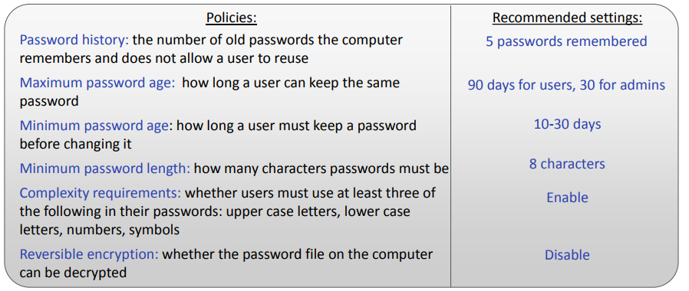

**Find Groups - cmd - whoami /groups**